Chapter 13, Problem 36.
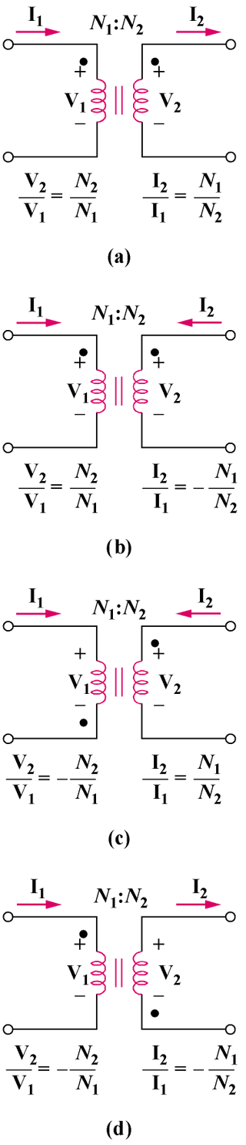  Figure 13.32  For Prob. 13.36. | 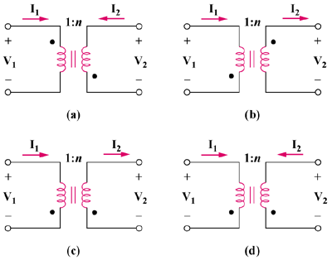  Figure 13.104  For Prob. 13.36.
As done in Fig. 13.32, obtain the relationships between terminal voltages and currents for each of the ideal transformers in Fig. 13.104.

